Anapestic Trimeter

📏 What is Anapestic Trimeter
# Source: AI Source: Provided by: [Data Path: Persons Table -> ID Column: 1, Name_En Column: Motasem Essam] -> From: [Chatgpt (GPT-4-turbo)] on [8/2/2025]
Anapestic Trimeter is a poetic meter that consists of:
- Three anapests per line
- An anapest = two unstressed syllables followed by a stressed syllable
→ da-da-DUM da-da-DUM da-da-DUM

🧱 Structure
# Source: AI Source: Provided by: [Data Path: Persons Table -> ID Column: 1, Name_En Column: Motasem Essam] -> From: [Chatgpt (GPT-4-turbo)] on [8/2/2025]
- 9 syllables per line (3 × 3 syllables)
- Rhythm pattern: × × / × × / × × /
(× = unstressed, / = stressed)

📝 Examples
# Source: AI Source: Provided by: [Data Path: Persons Table -> ID Column: 1, Name_En Column: Motasem Essam] -> From: [Chatgpt (GPT-4-turbo)] on [8/2/2025]
’Twas the night before Christmas, and all through the house
— Clement Clarke Moore
With a love that the wingèd seraphs of Heaven
— Edgar Allan Poe

🔀 Variations & Flexibility
# Source: AI Source: Provided by: [Data Path: Persons Table -> ID Column: 1, Name_En Column: Motasem Essam] -> From: [Chatgpt (GPT-4-turbo)] on [8/2/2025]
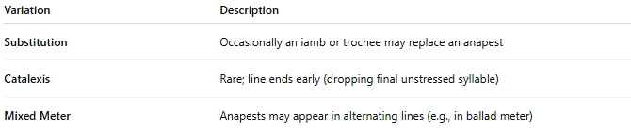
Variation | Description
Substitution | Occasionally an iamb or trochee may replace an anapest
Catalexis | Rare; line ends early (dropping final unstressed syllable)
Mixed Meter | Anapests may appear in alternating lines (e.g., in ballad meter)

🧬 Poetic Use & Effect
# Source: AI Source: Provided by: [Data Path: Persons Table -> ID Column: 1, Name_En Column: Motasem Essam] -> From: [Chatgpt (GPT-4-turbo)] on [8/2/2025]
- Often produces a galloping, lilting, or musical quality
- Common in narrative poems, comedic verse, and light verse
- Adds a sense of momentum, anticipation, or whimsy

🏛️ Where It’s Found
# Source: AI Source: Provided by: [Data Path: Persons Table -> ID Column: 1, Name_En Column: Motasem Essam] -> From: [Chatgpt (GPT-4-turbo)] on [8/2/2025]
- Found in 19th-century narrative poetry
- Used in children’s literature, humorous poetry, and seasonal verse
- Appears in the works of Moore, Poe, and Dr. Seuss

